Homework 6 for GPI

1. KK 4.23 （6.5）
2. KK.4.28 (6.13)
3. KK 4.29 (6.14)
4. KK 4.30 (6.16)
5. Some practice on partial derivatives:
6. A function called Lagrange is given by: , it is a function explicitly depend on vx,vy and t. Also we know that the velocities are related to time:

. Find the following derivatives: 1) The partial derivative of L vs. t; vs. vx. 2) The total derivative (i.e. as t changes by small amount, how much L will change): . Understand the difference between this vs. in 1).

1. , an equation represents a ellipse, use the partial derivative method to find dy/dx (the tangent line on the ellipse)
2. For a function of 
3. Find 
4. Now I make a transformation, using s,t as variable instead of x,y and they are related by: s=x, t=x+y, now find , is it same as ?

Following are the problems on gradient, line integral and Green (Stokes) Theorem:

1. KK 5.1

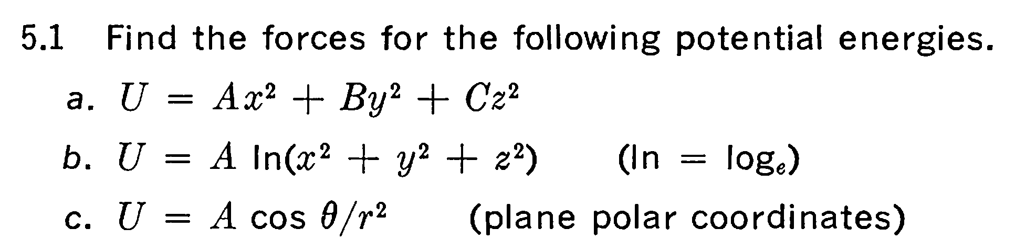

1. KK 5.4

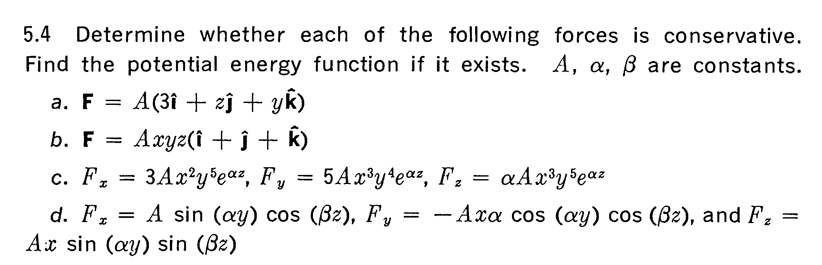

1. KK 5.5 (Try U=C, U=2C and you will see what the contours(equal potential lines) look alike)

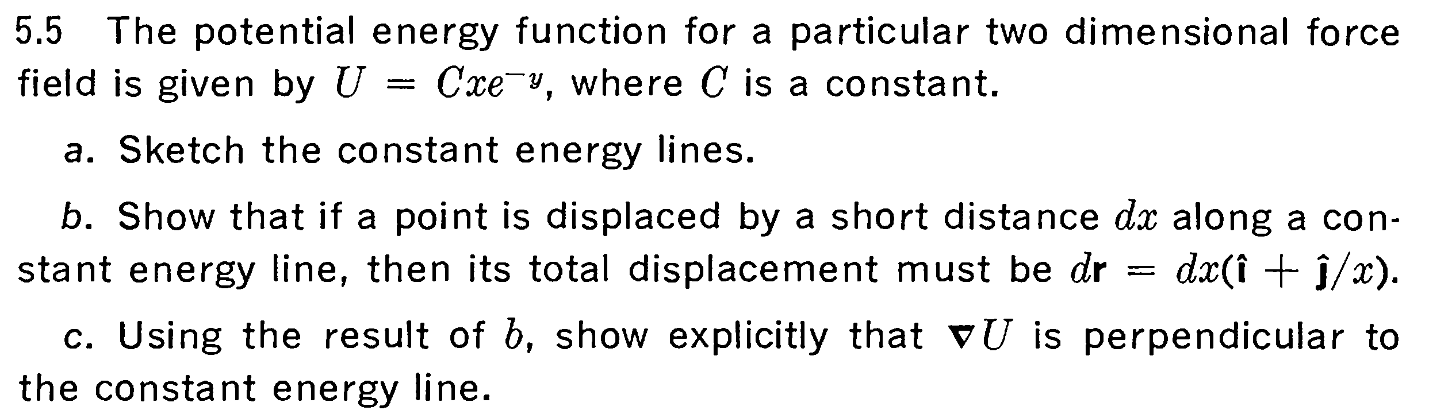

1. KK 5.7

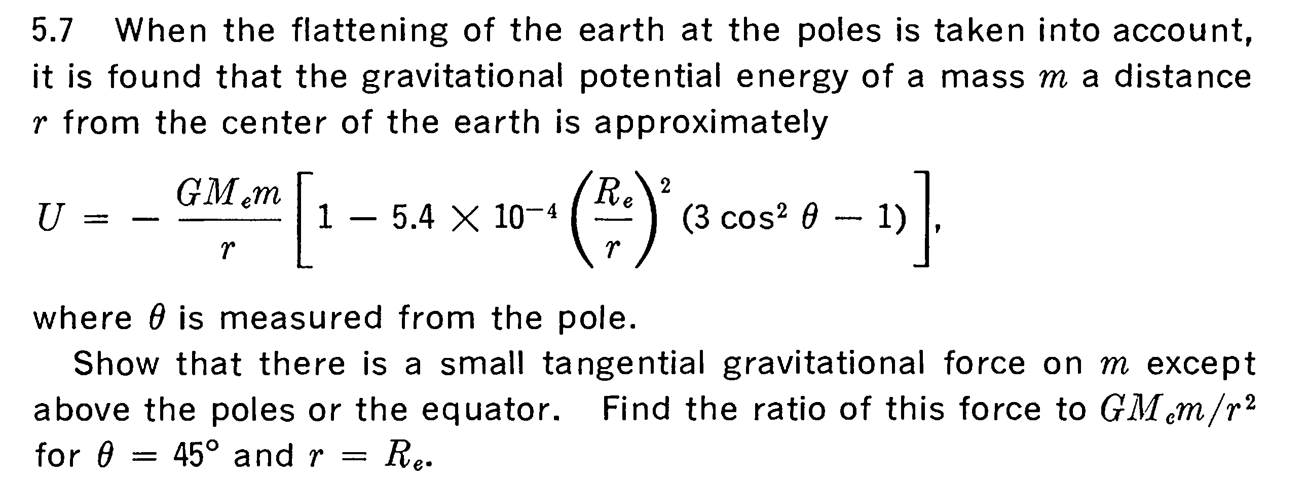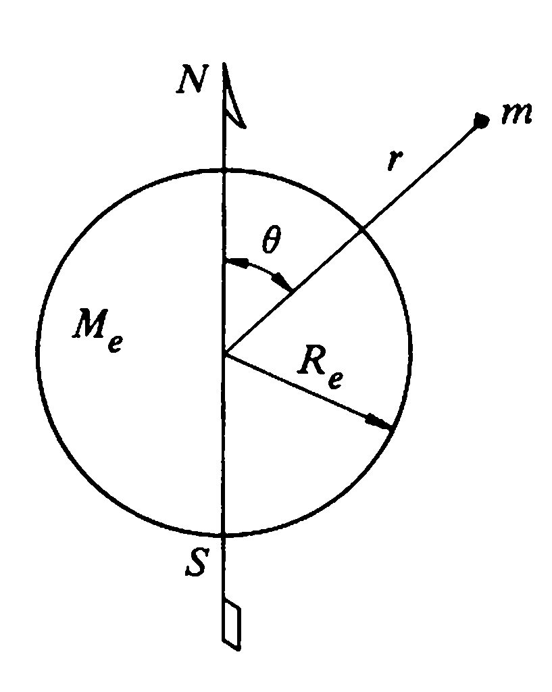

1. KK 5.8

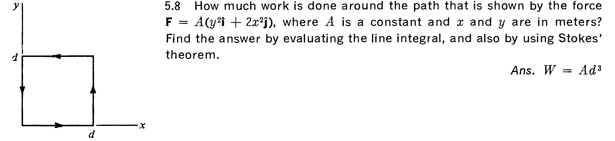

If you have spare time, try to derive the gradient formula in spherical coordinate system.